Step 1:

Select Dynamo DB

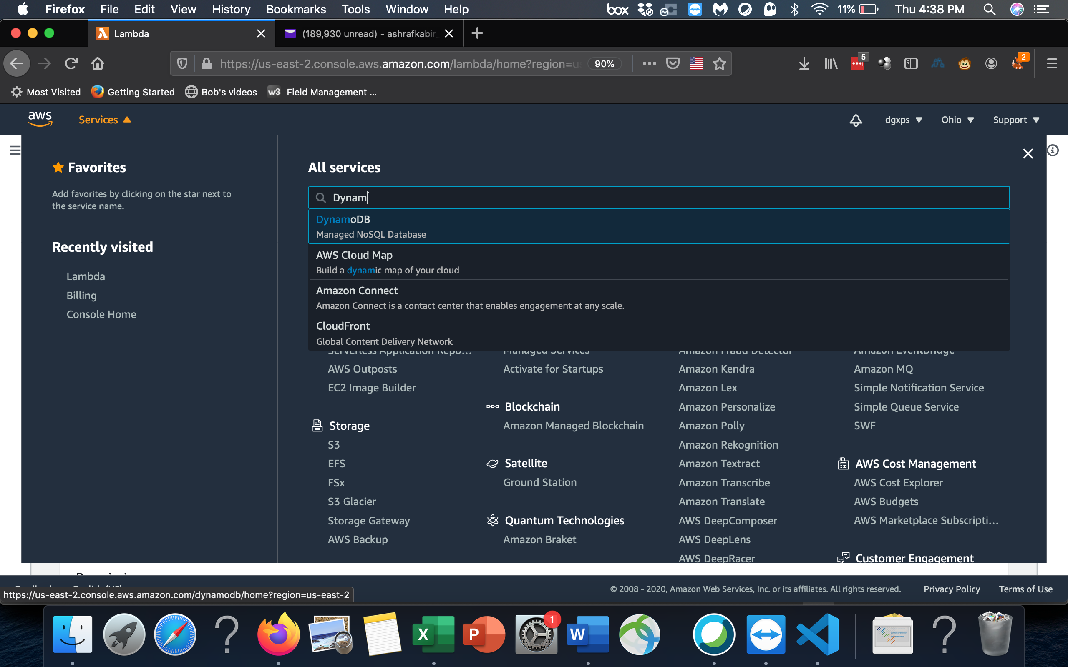



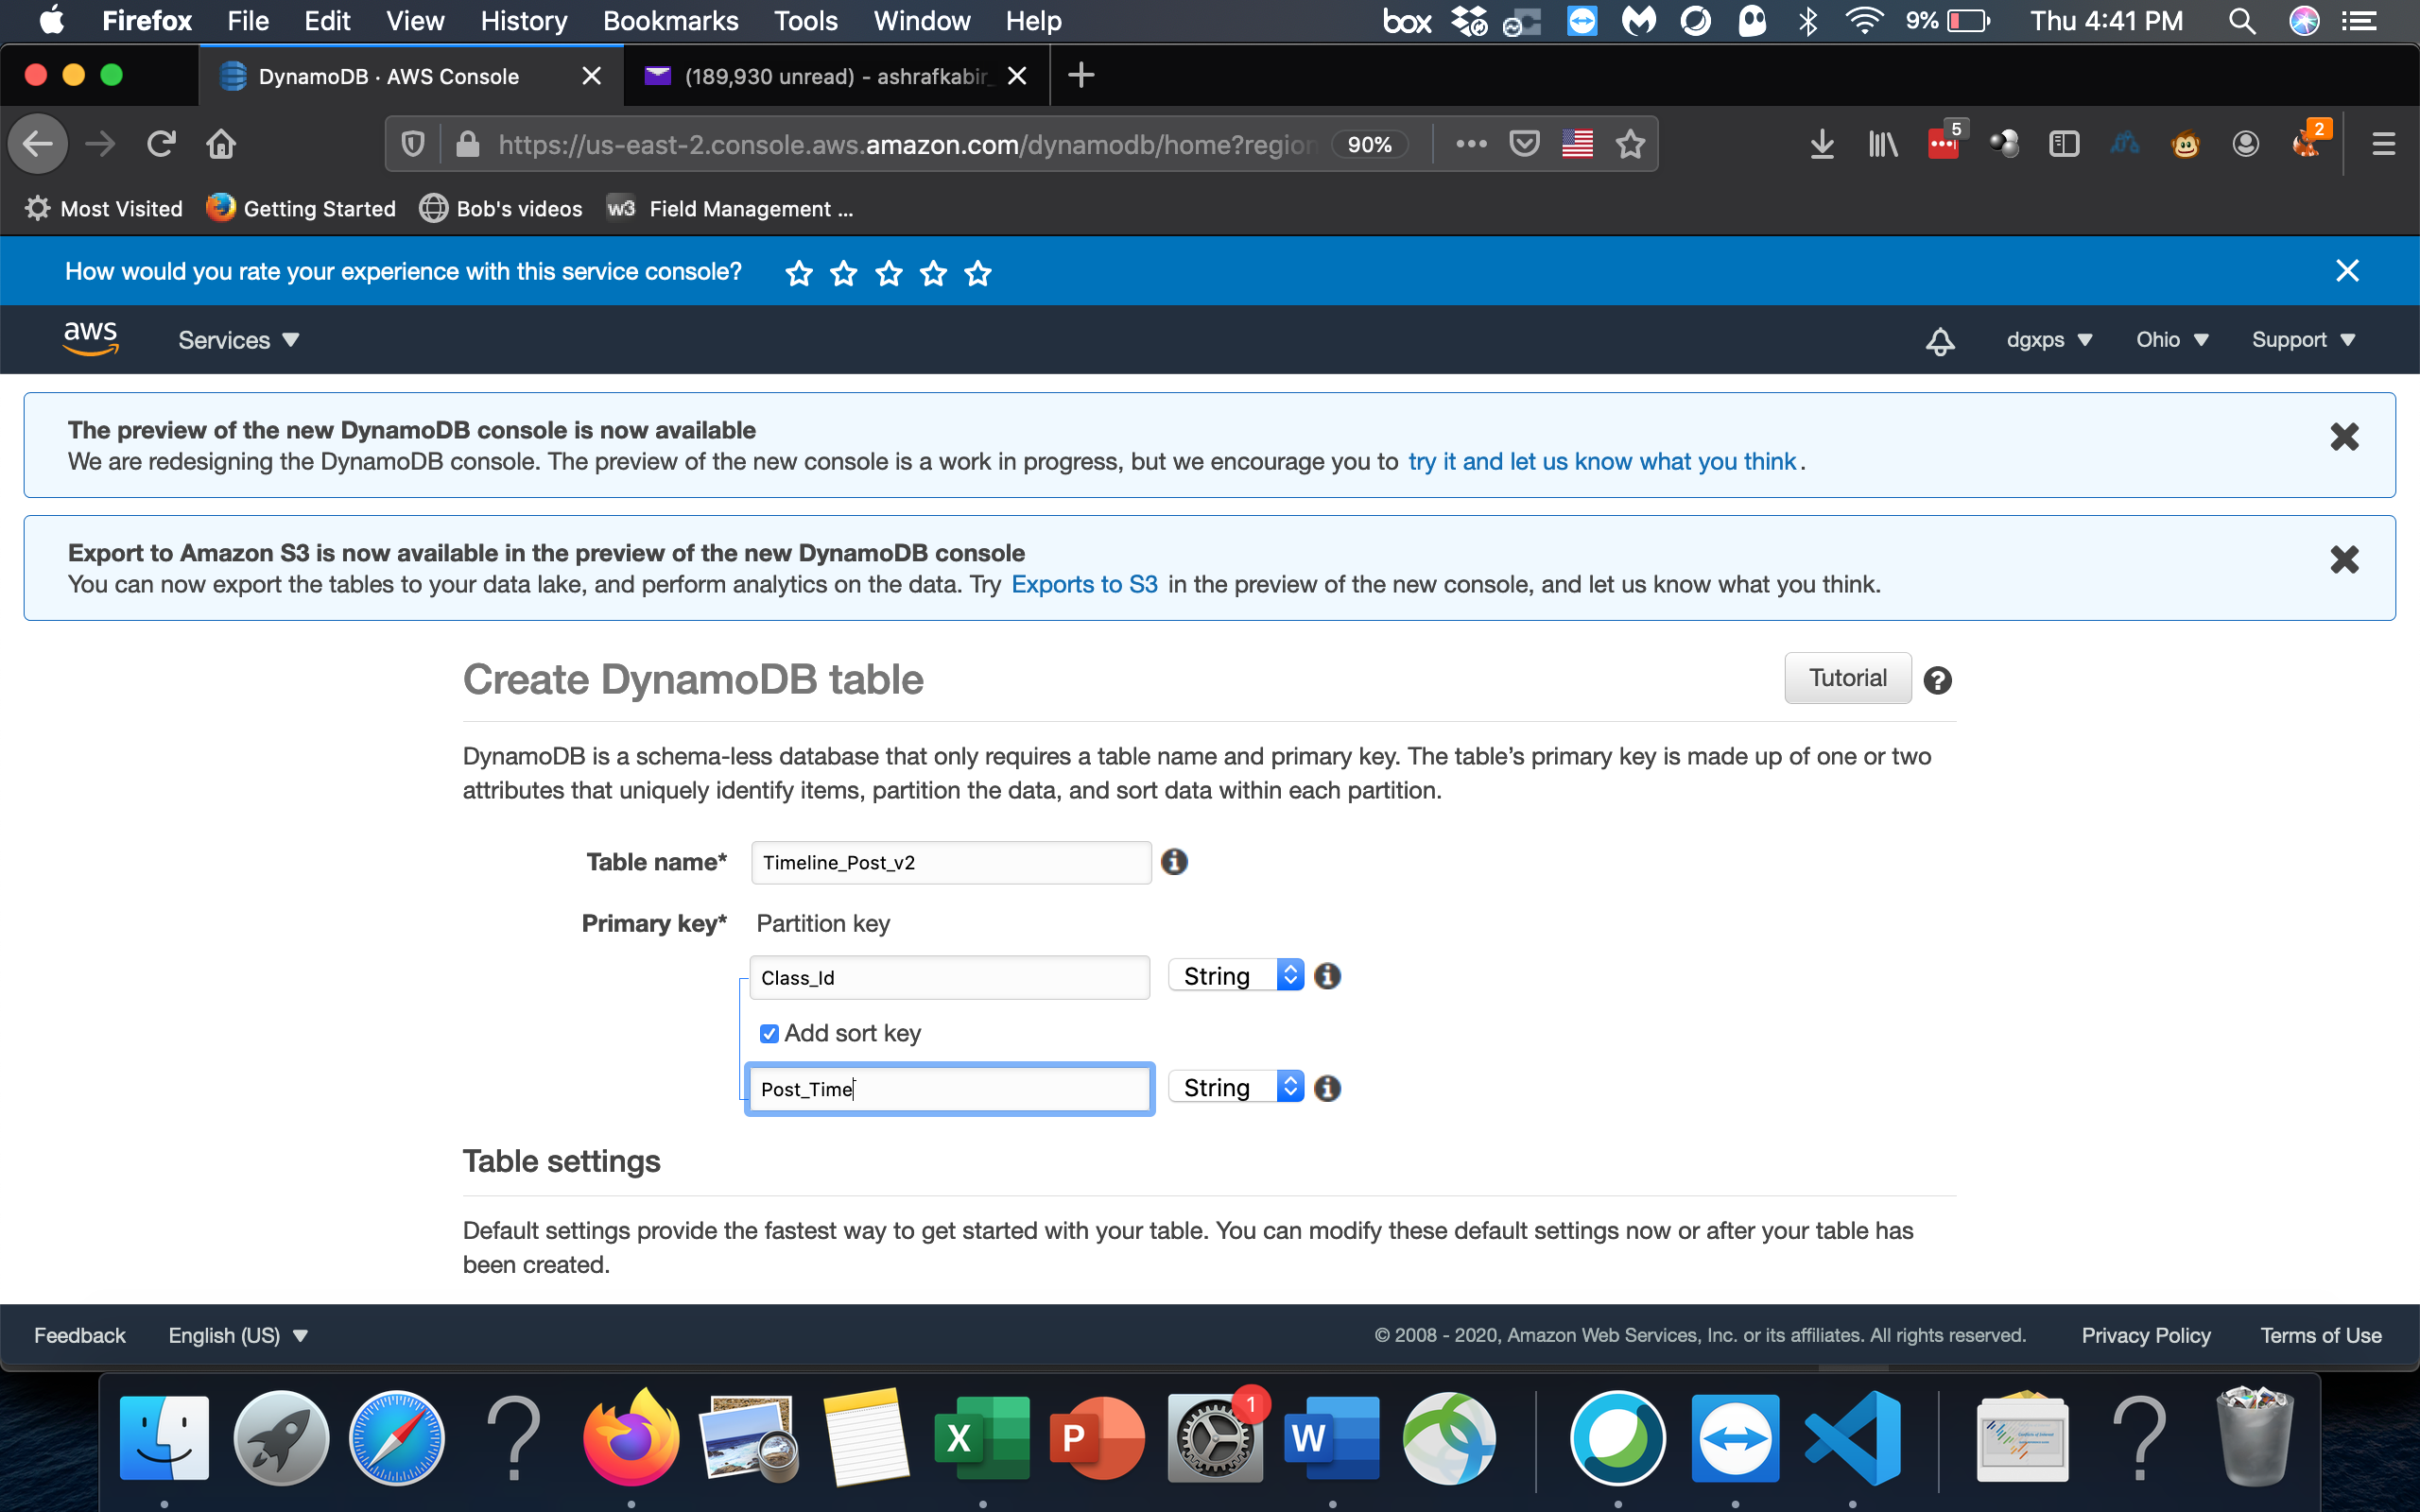

Table is now created.

Step 2: Now create MS

Select Lambda from services menu

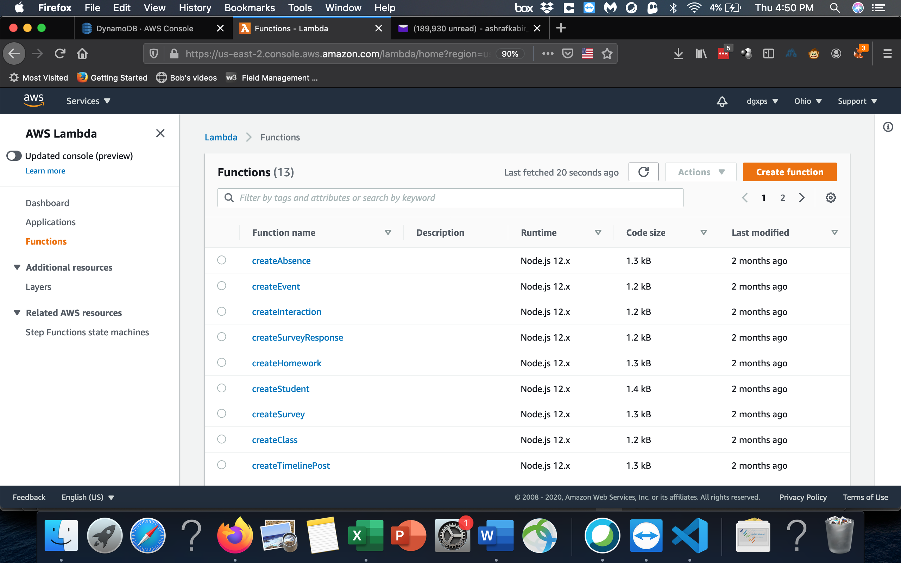

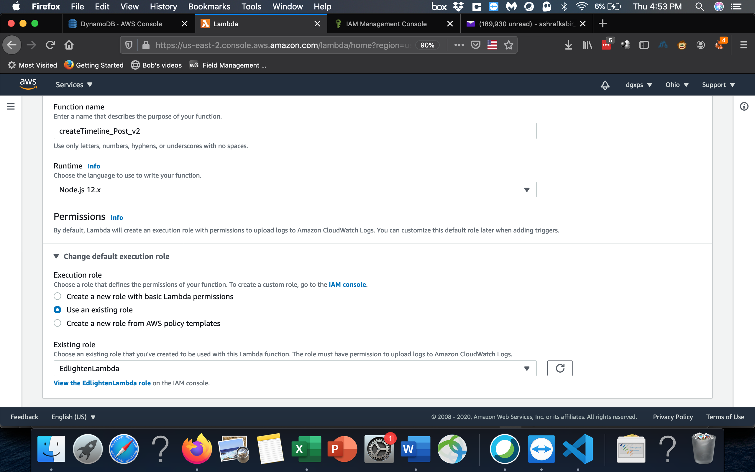

Copy code from template:

const randomBytes = require('crypto').randomBytes;

const AWS = require('aws-sdk');

const ddb = new AWS.DynamoDB.DocumentClient();

exports.handler = (event, context, callback) => {

// The body field of the event in a proxy integration is a raw string.

// In order to extract meaningful values, we need to first parse this string

// into an object. A more robust implementation might inspect the Content-Type

// header first and use a different parsing strategy based on that value.

const requestBody = JSON.parse(event.body);

const Class_ID = requestBody.Class_ID;

const Comments = requestBody.Comments;

const Fees_Id = requestBody.Fees_Id;

const Homework_ID = requestBody.Homework_ID;

const Likes = requestBody.Likes;

const Post_Author = requestBody.Post_Author;

const Post_Body = requestBody.Post_Body;

const Post_ID = requestBody.Post_ID;

const Post_Time = requestBody.Post_Time;

const Post_Title = requestBody.Post_Title;

const Post_Type = requestBody.Post_Type;

const Survey_ID = requestBody.Survey_ID;

recordTimelinePost(Class_ID,

Comments,

Fees_Id,

Homework_ID,

Likes,

Post_Author,

Post_Body,

Post_ID,

Post_Time,

Post_Title,

Post_Type,

Survey_ID).then(() => {

// You can use the callback function to provide a return value from your Node.js

// Lambda functions. The first parameter is used for failed invocations. The

// second parameter specifies the result data of the invocation.

// Because this Lambda function is called by an API Gateway proxy integration

// the result object must use the following structure.

callback(null, {

statusCode: 201,

body: JSON.stringify({

Class_ID:Class_ID,

Comments:Comments,

Fees_Id:Fees_Id,

Homework_ID:Homework_ID,

Likes:Likes,

Post_Author:Post_Author,

Post_Body:Post_Body,

Post_ID:Post_ID,

Post_Time:Post_Time,

Post_Title:Post_Title,

Post_Type:Post_Type,

Survey_ID:Survey_ID

}),

headers: {

'Access-Control-Allow-Origin': '*',

},

});

}).catch((err) => {

console.error(err);

// If there is an error during processing, catch it and return

// from the Lambda function successfully. Specify a 500 HTTP status

// code and provide an error Student in the body. This will provide a

// more meaningful error response to the end client.

errorResponse(err.Student, context.awsRequestId, callback)

});

};

function recordTimelinePost(Class_ID,

Comments,

Fees_Id,

Homework_ID,

Likes,

Post_Author,

Post_Body,

Post_ID,

Post_Time,

Post_Title,

Post_Type,

Survey_ID) {

return ddb.put({

TableName: 'Timeline_Post',

Item: {

Class_ID:Class_ID,

Comments:Comments,

Fees_Id:Fees_Id,

Homework_ID:Homework_ID,

Likes:Likes,

Post_Author:Post_Author,

Post_Body:Post_Body,

Post_ID:Post_ID,

Post_Time:Post_Time,

Post_Title:Post_Title,

Post_Type:Post_Type,

Survey_ID:Survey_ID,

Created_On: new Date().toISOString(),

},

}).promise();

}

function toUrlString(buffer) {

return buffer.toString('base64')

.replace(/\+/g, '-')

.replace(/\//g, '_')

.replace(/=/g, '');

}

function errorResponse(errorStudent, awsRequestId, callback) {

callback(null, {

statusCode: 500,

body: JSON.stringify({

Error: errorStudent,

Reference: awsRequestId,

}),

headers: {

'Access-Control-Allow-Origin': '*',

},

});

}

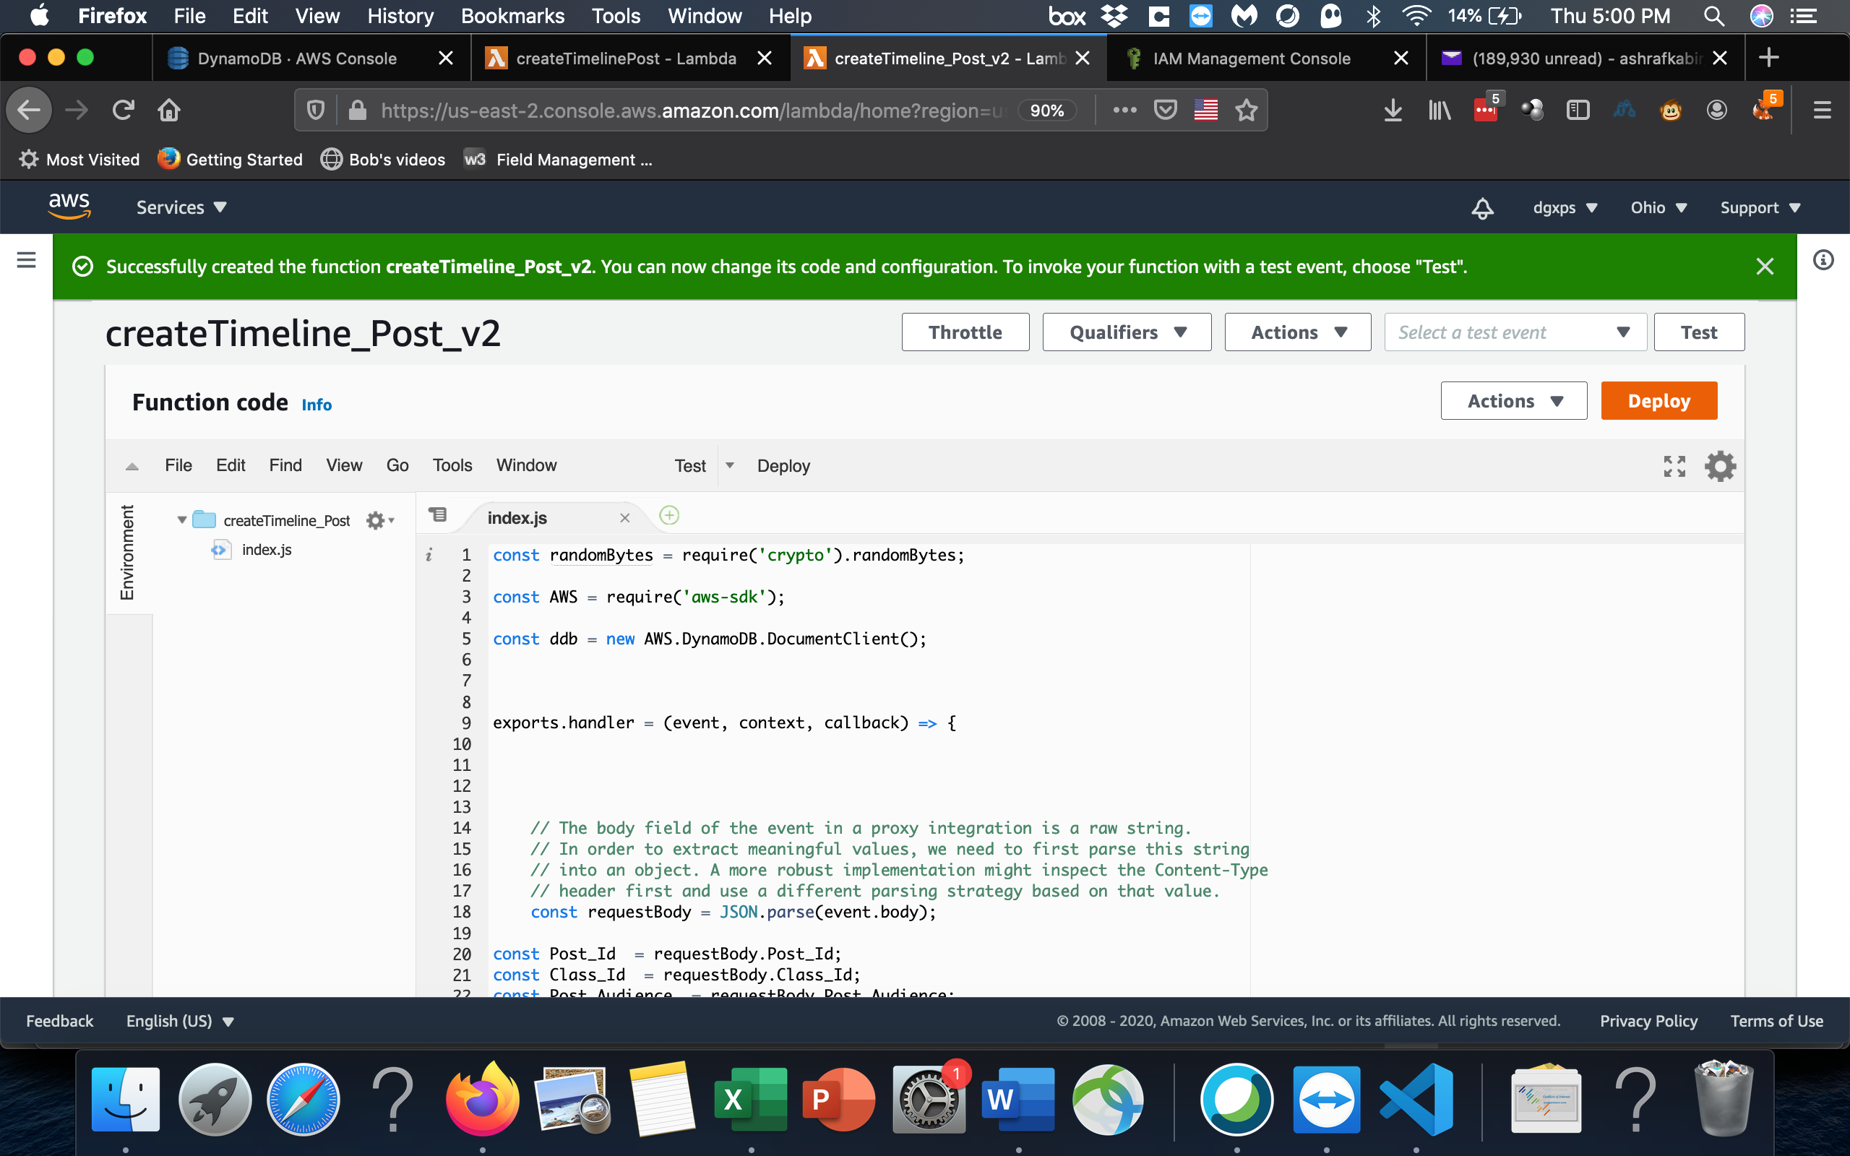

Click deploy

Step 3: Create API

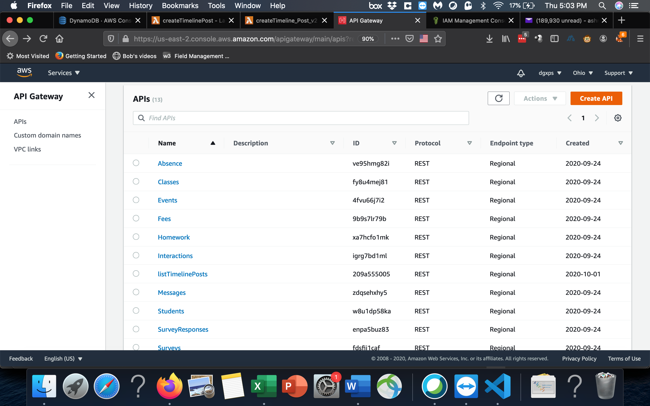

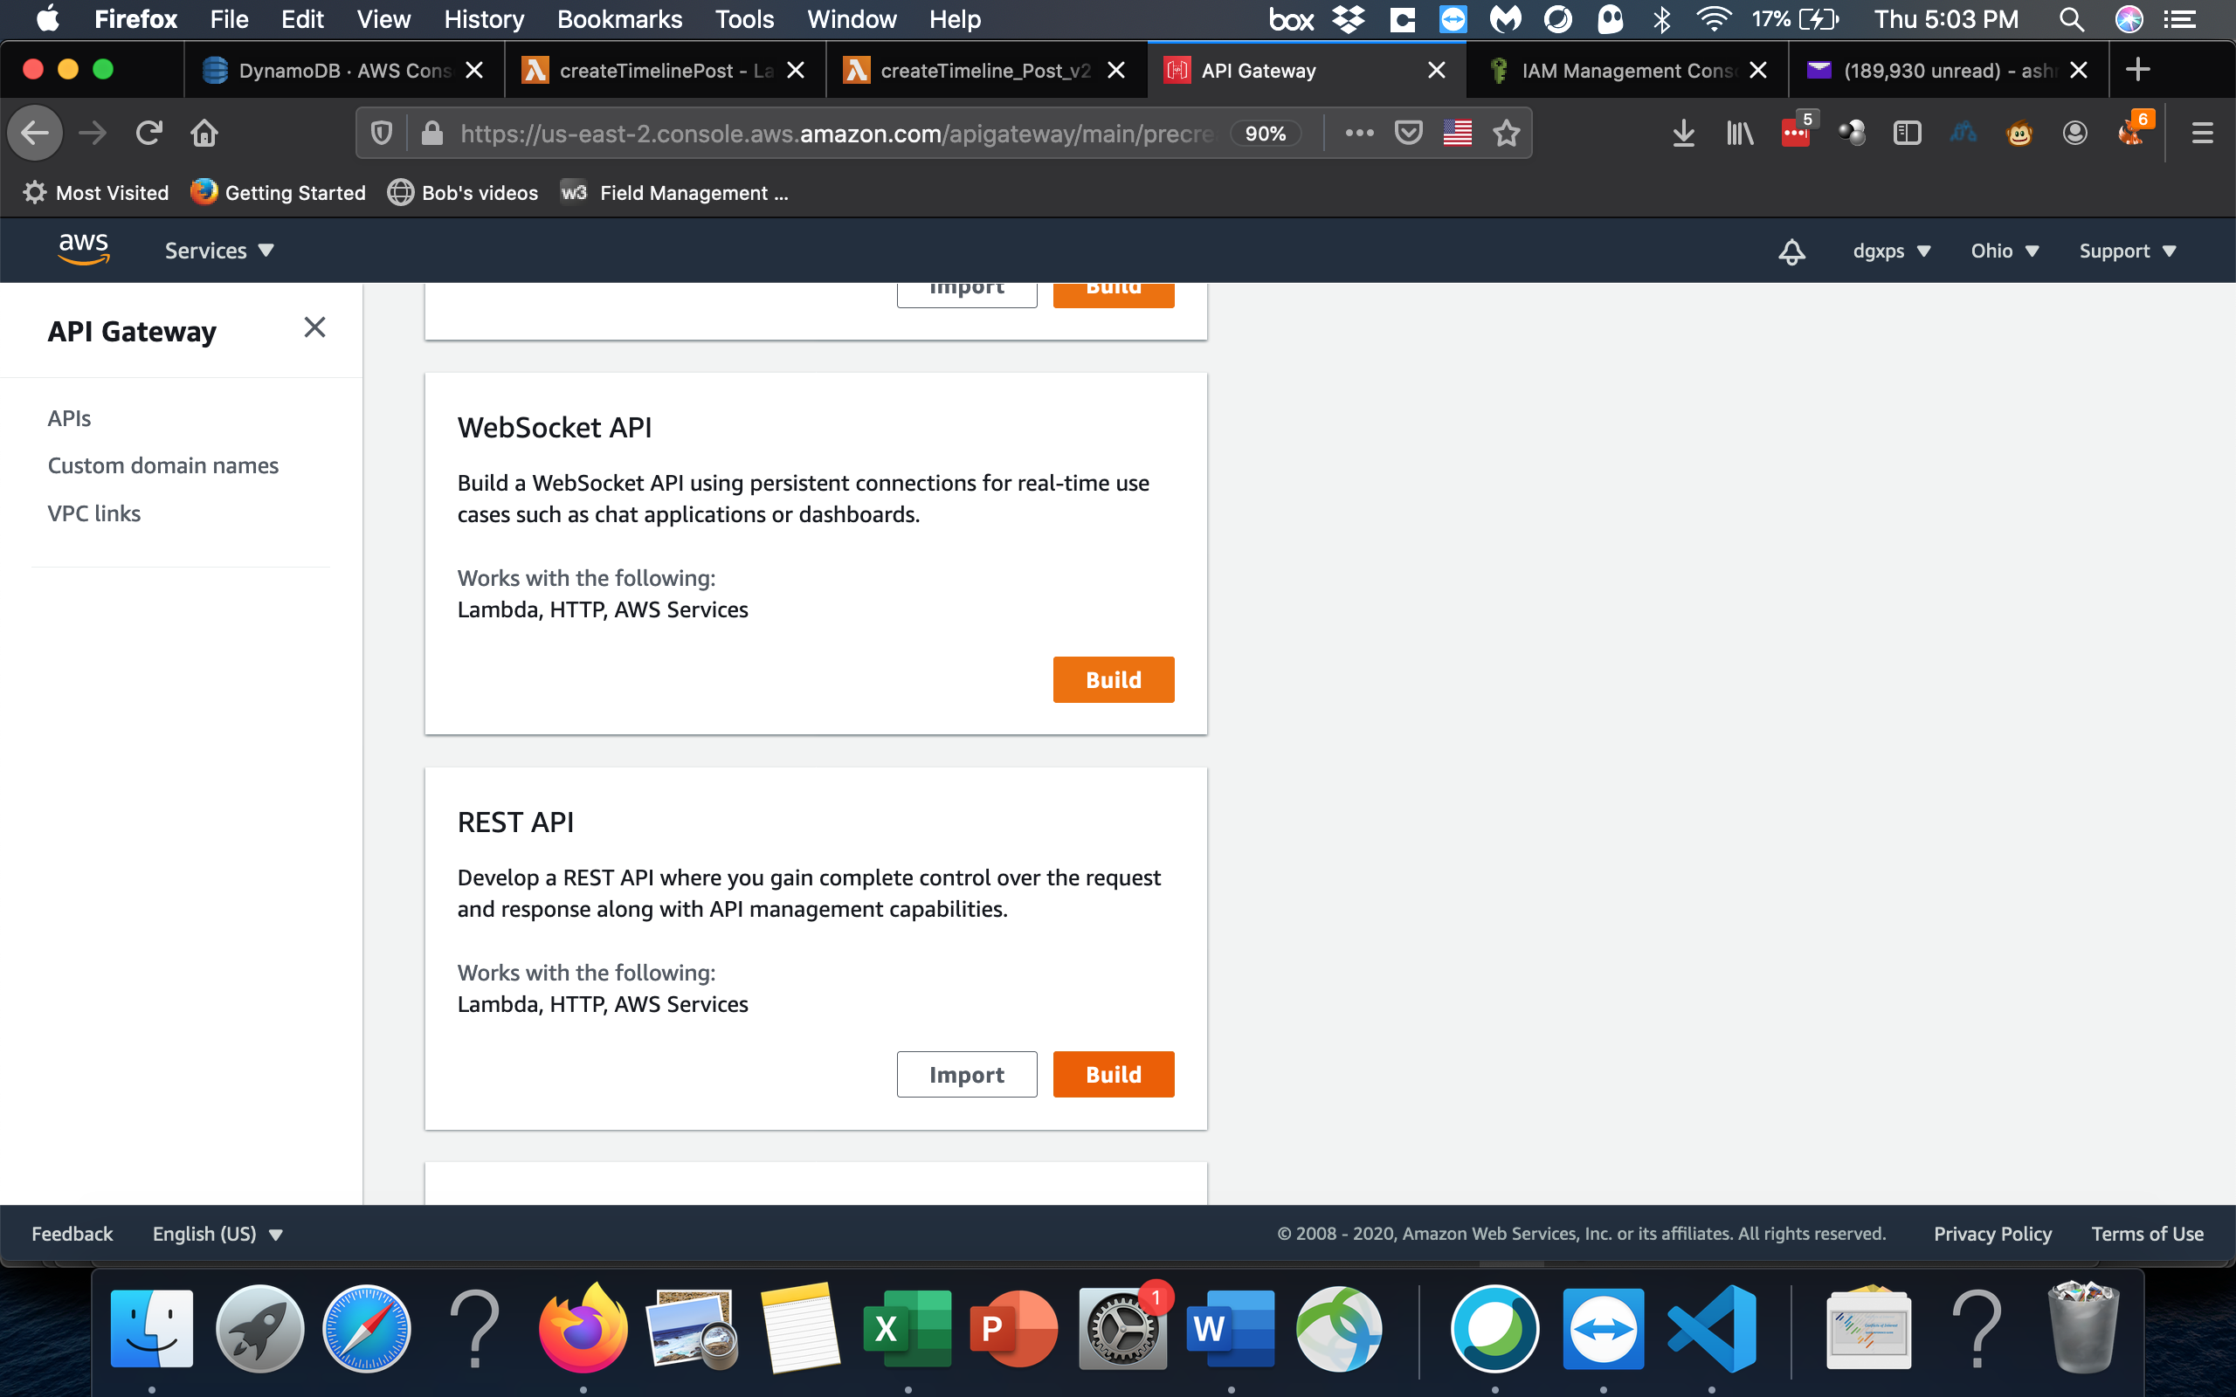

Select REST API

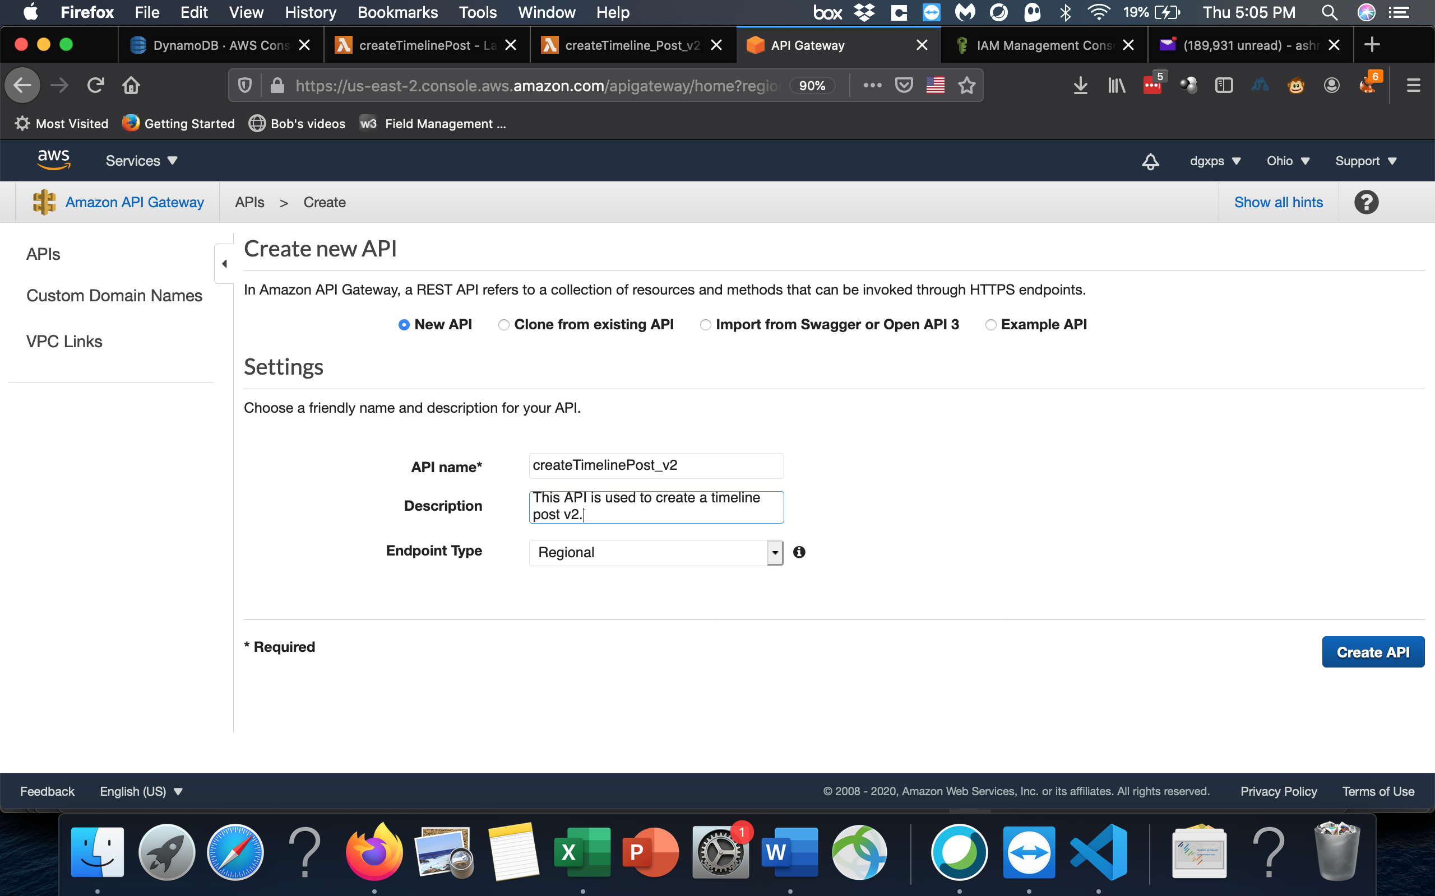

Create Resource as the path to the methods in the API

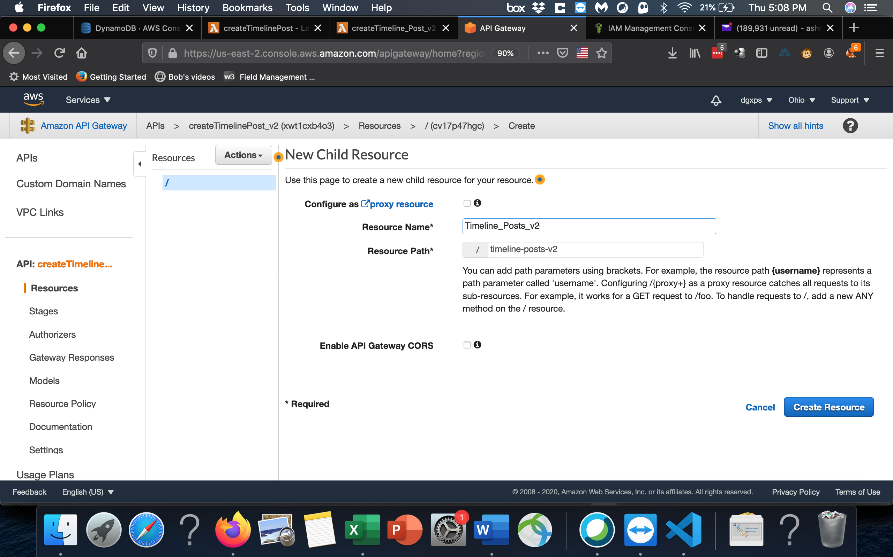

Create Post Method to add createTimeline_Post_v2 method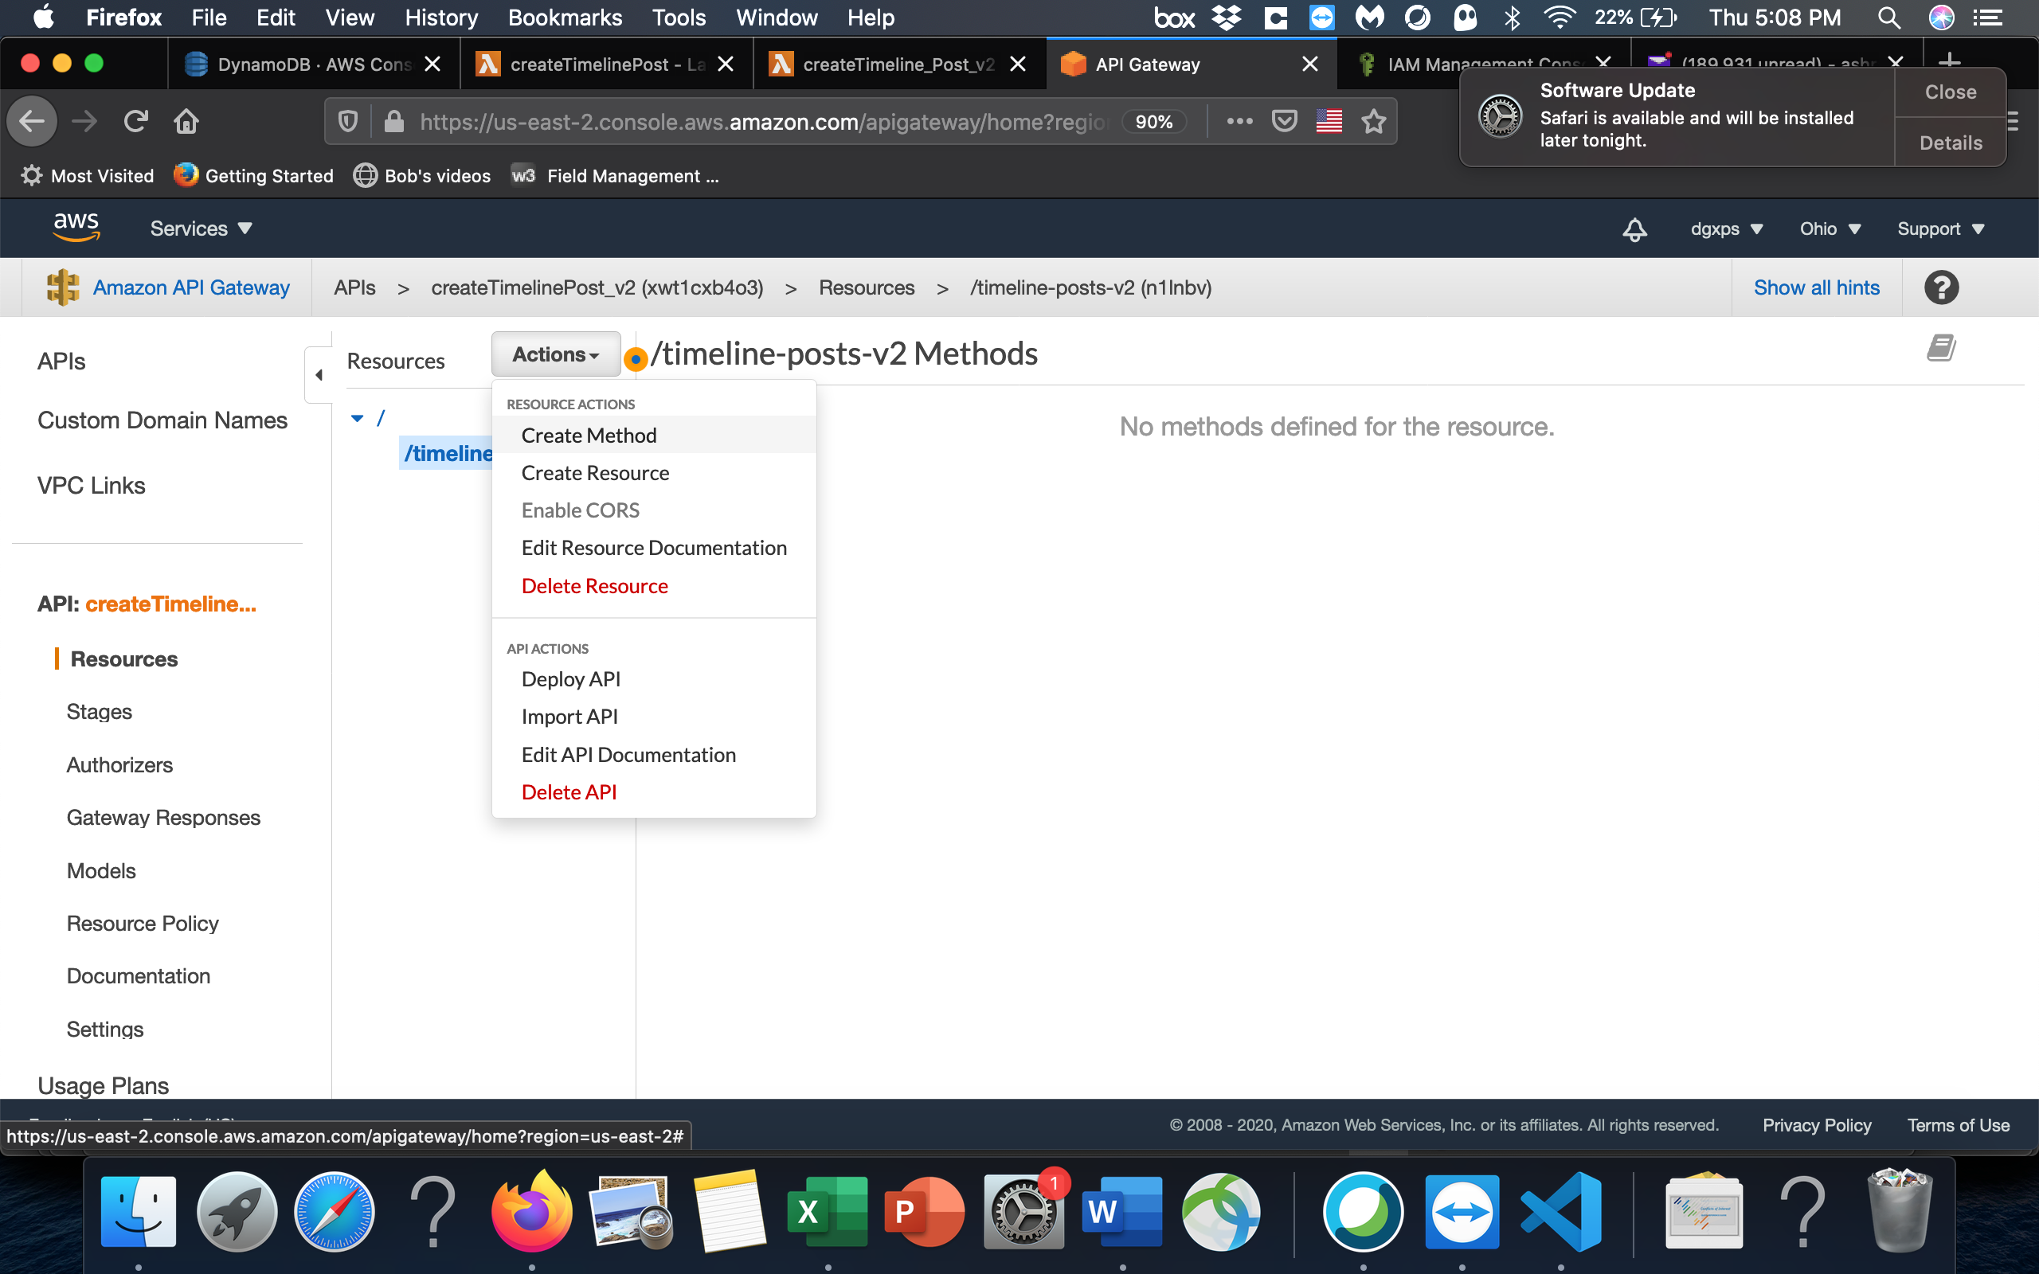

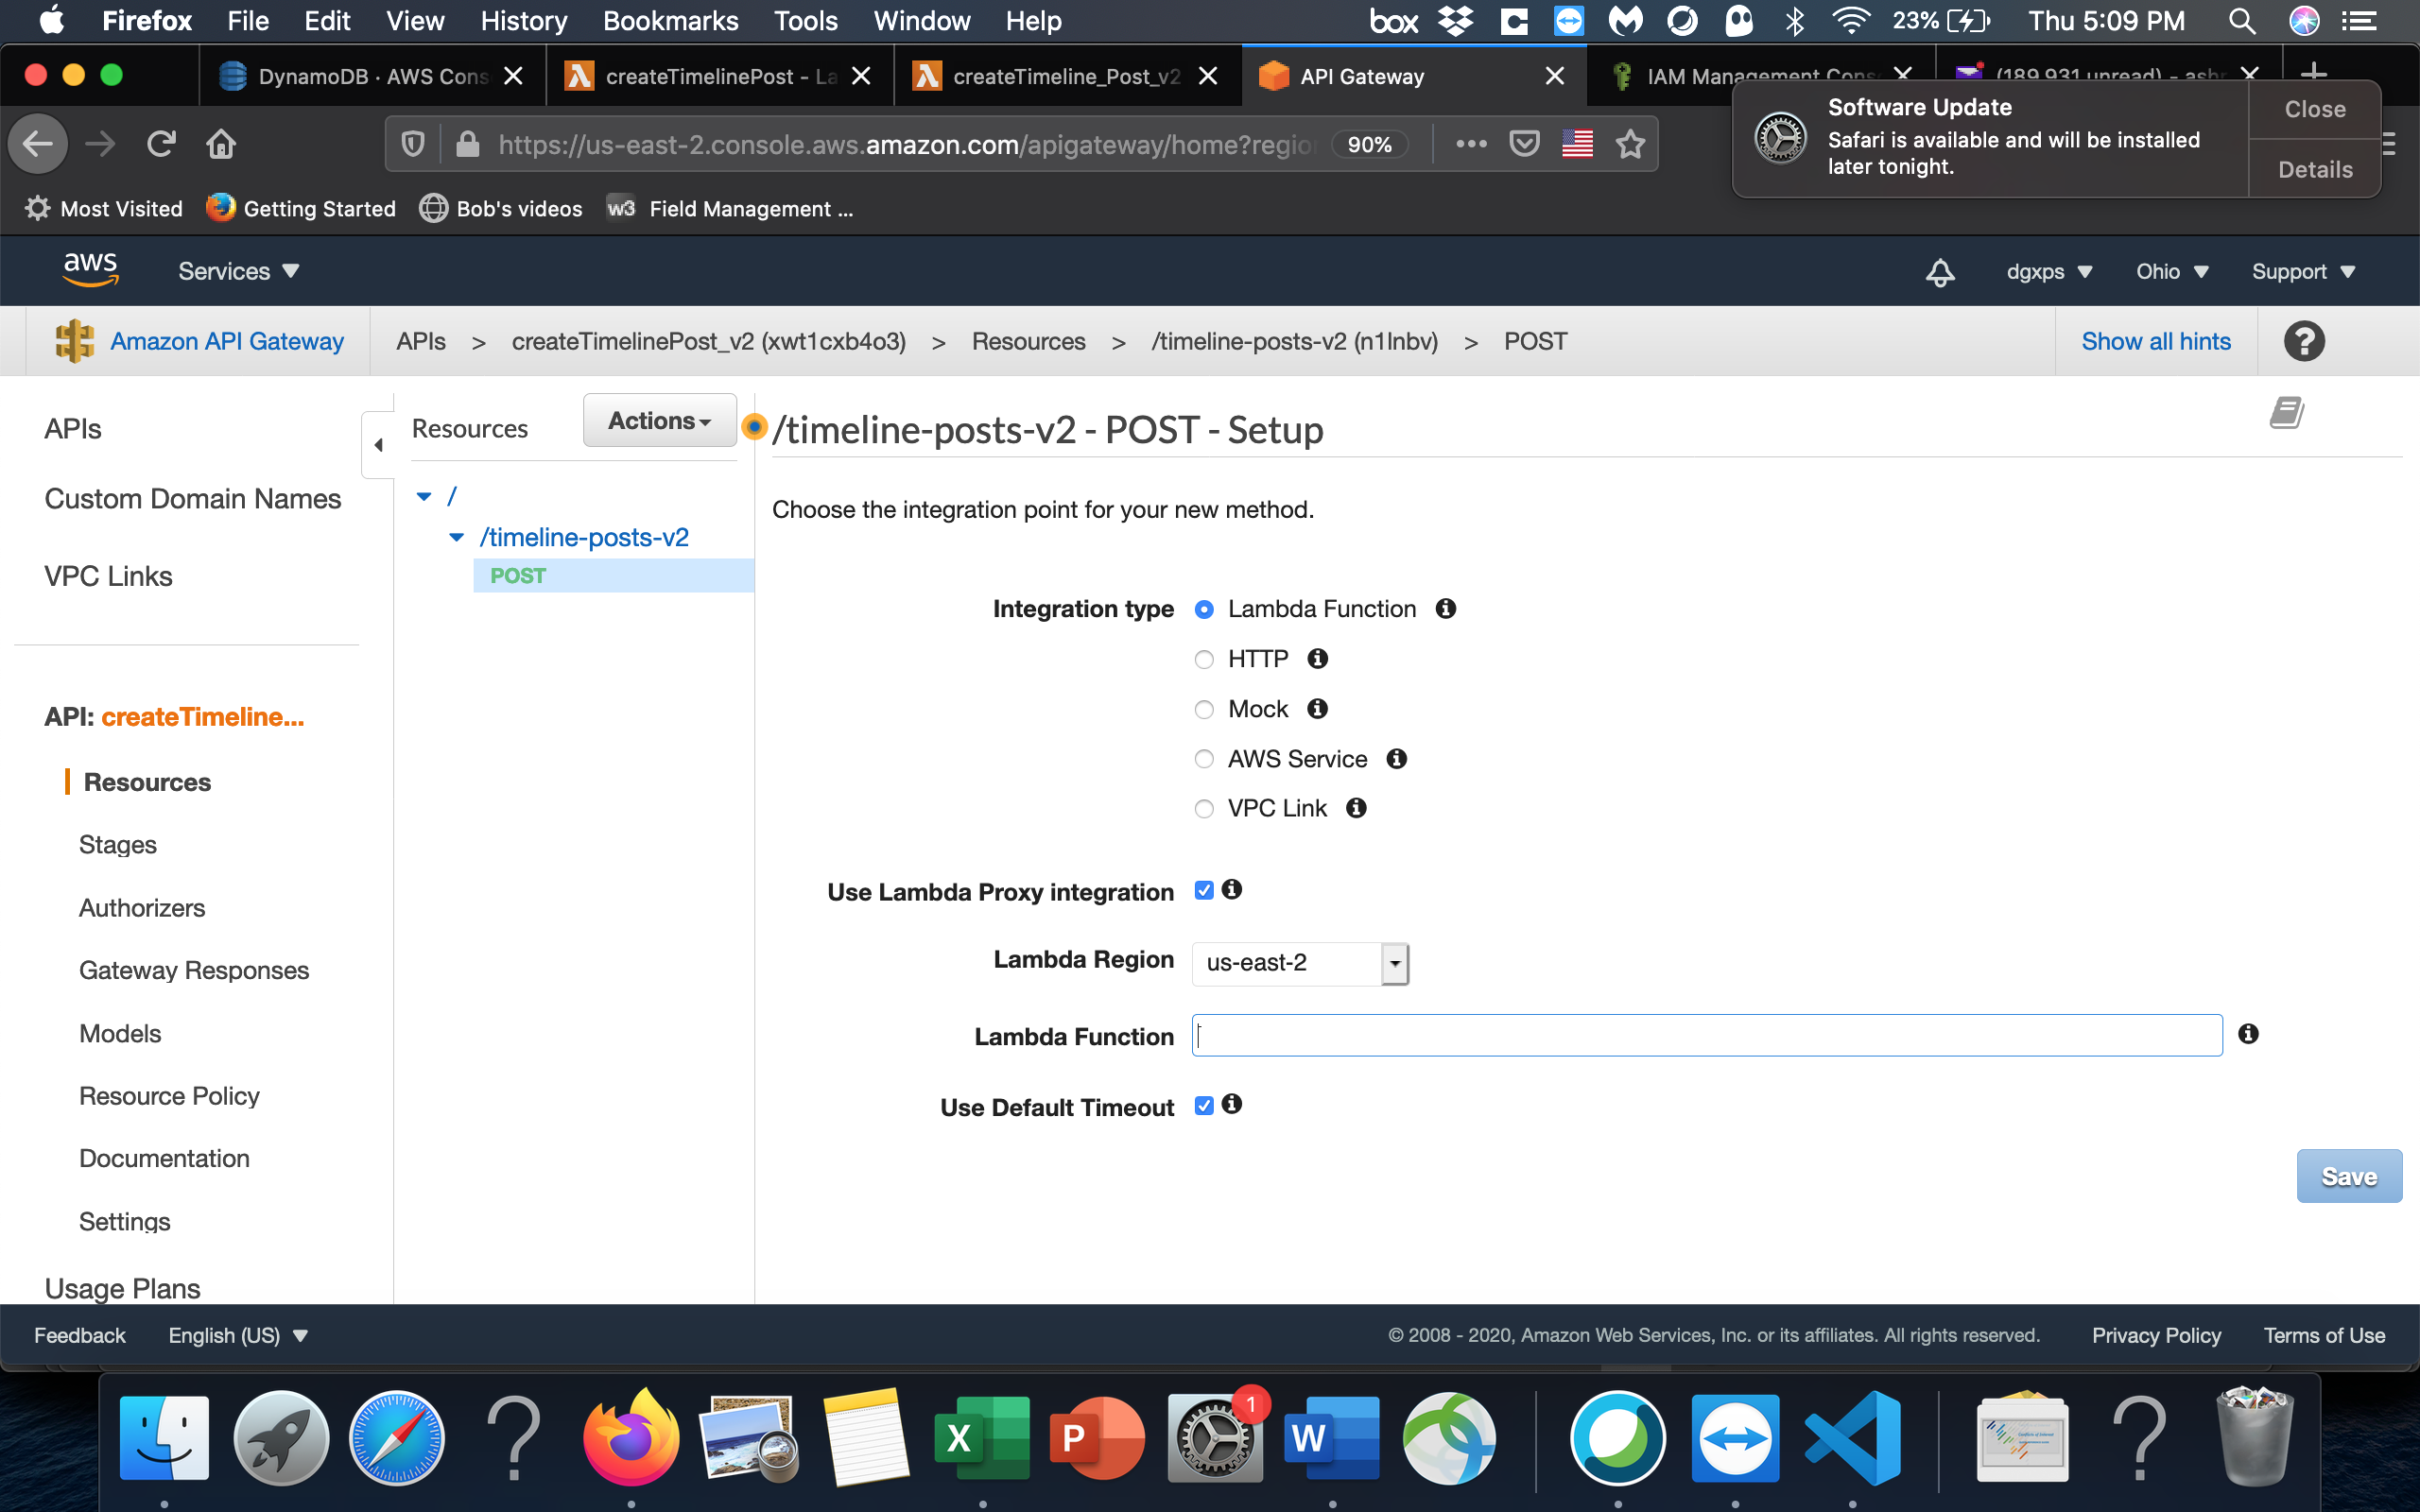

Now select the Lambda Integration Proxy and select the function to call

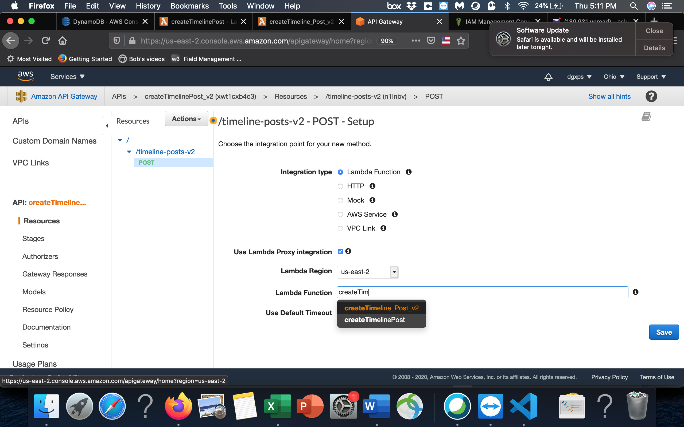

After you save click Deploy API

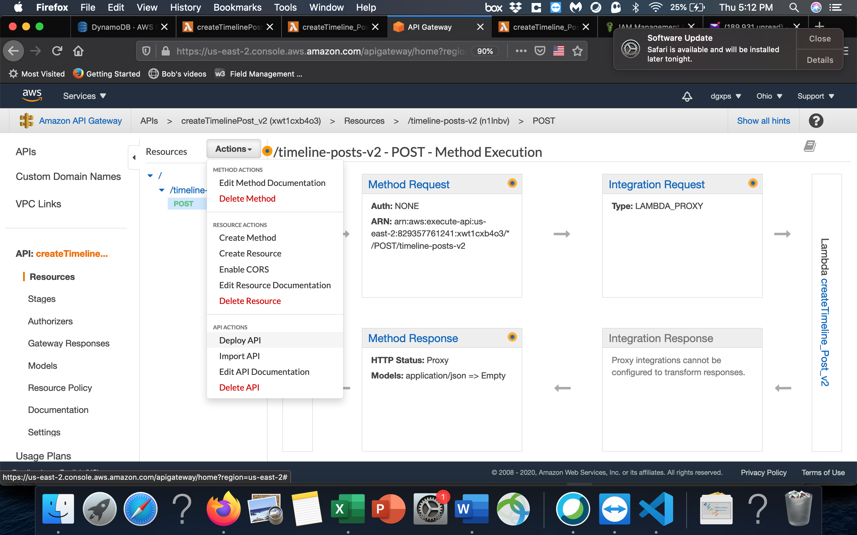

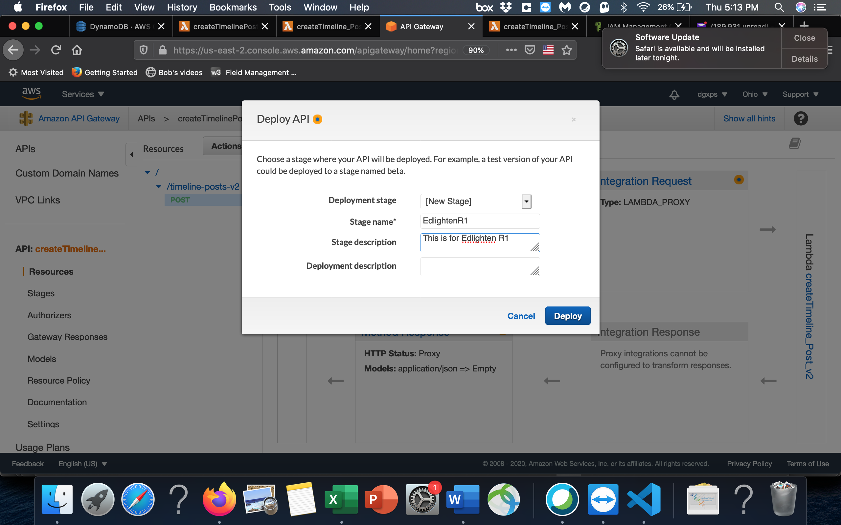

Copy the URL

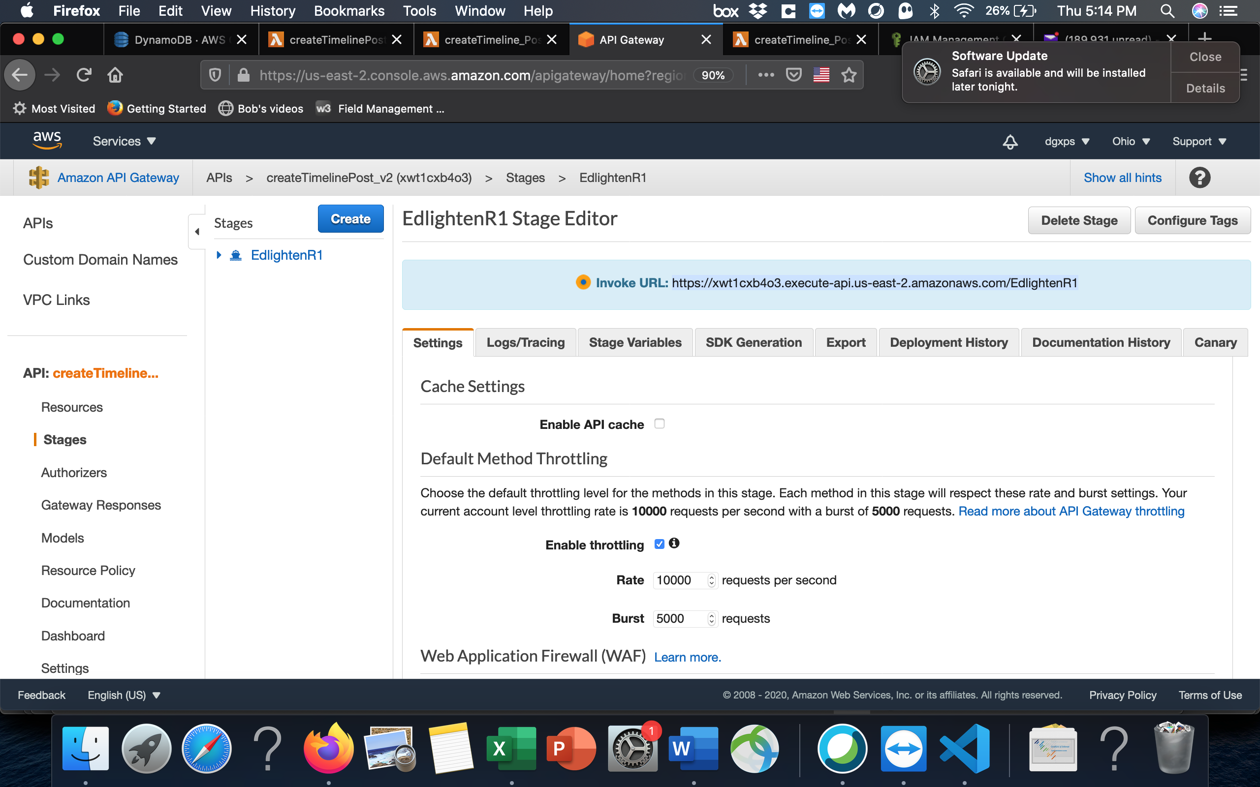

Now Open Postman on your laptop

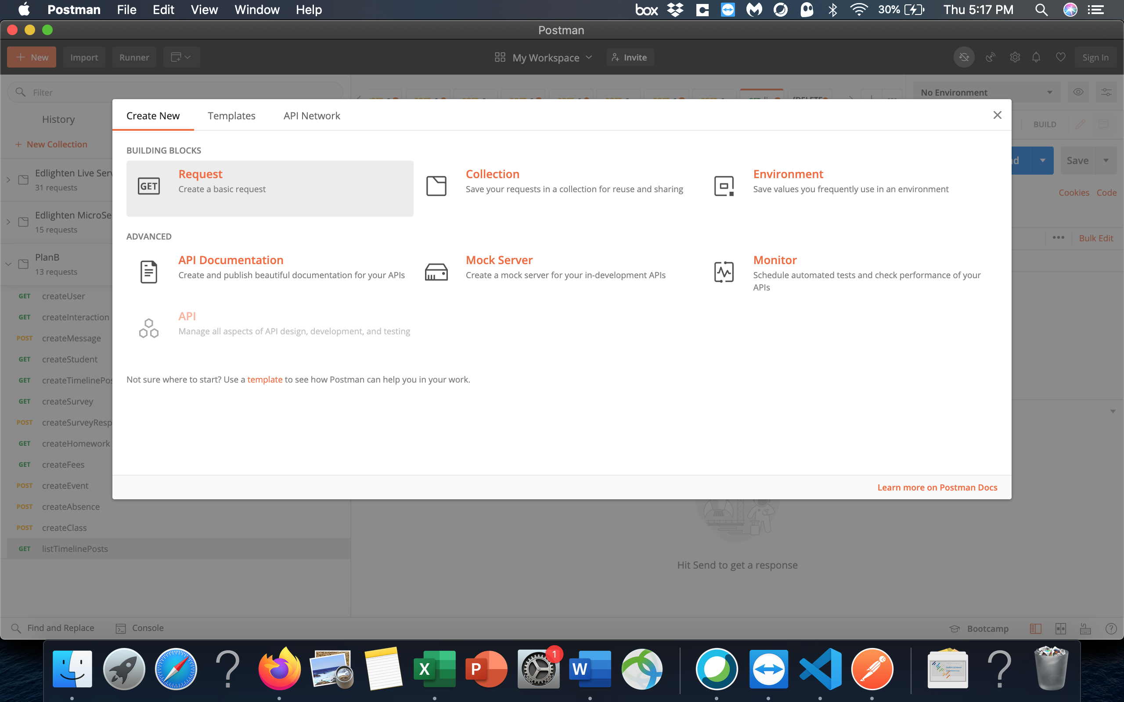

Create a new request

Paste the URL you copied.